**Assignment 3**

**Task :- 1] Create a Jinkins master and 2 slave machines.**

**2] Clone your project in slave machines and build the WAR file.**

**3] deploy the WAR file in slave machine.**

**Step 1**

**Launch ec2 instance and install all necessary software.(java, tomcat, Jenkins)**

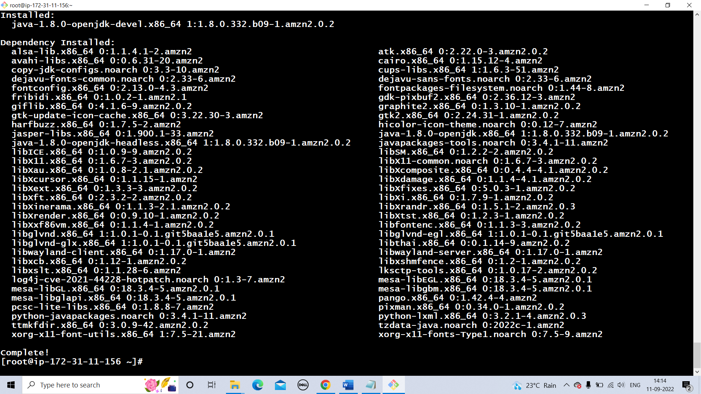

**Step 2**

**Make it as Jenkins master.**

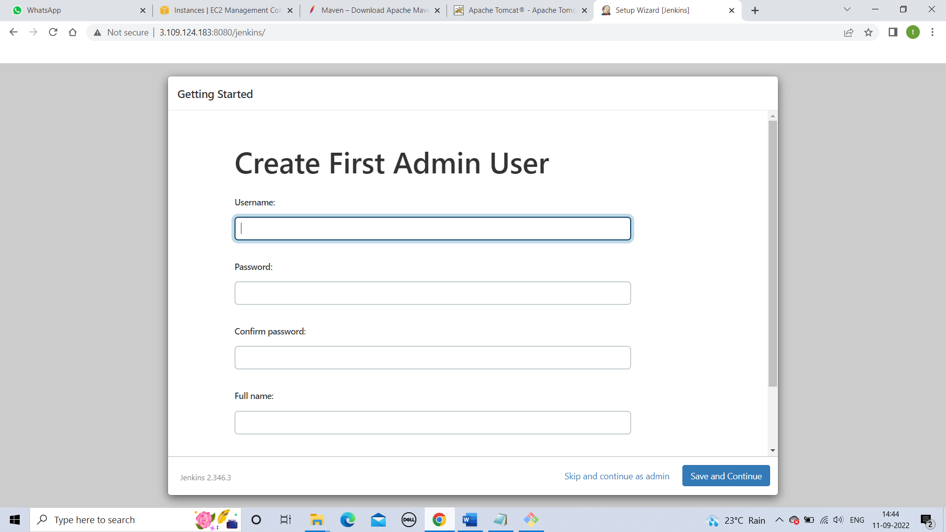

**Step 3**

**Launch a slave machine and install required software.(git, java, maven, tomcat)**

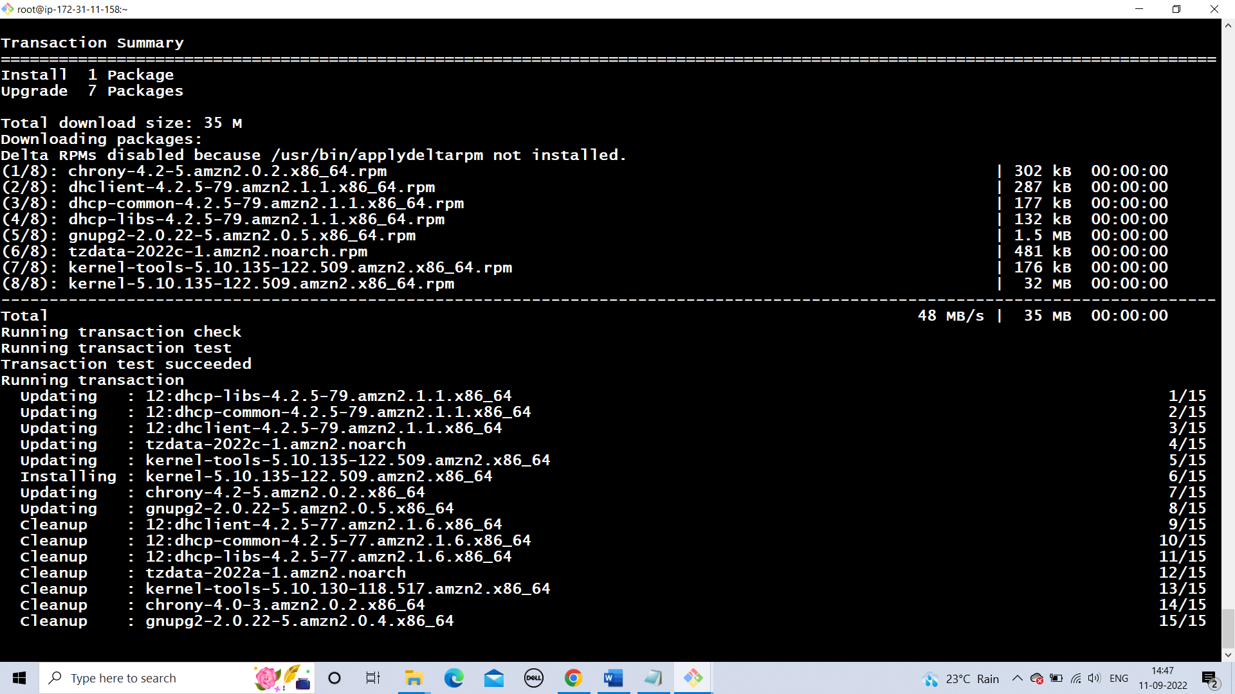

**Step 4**

**In global tool configuration and maven details.**

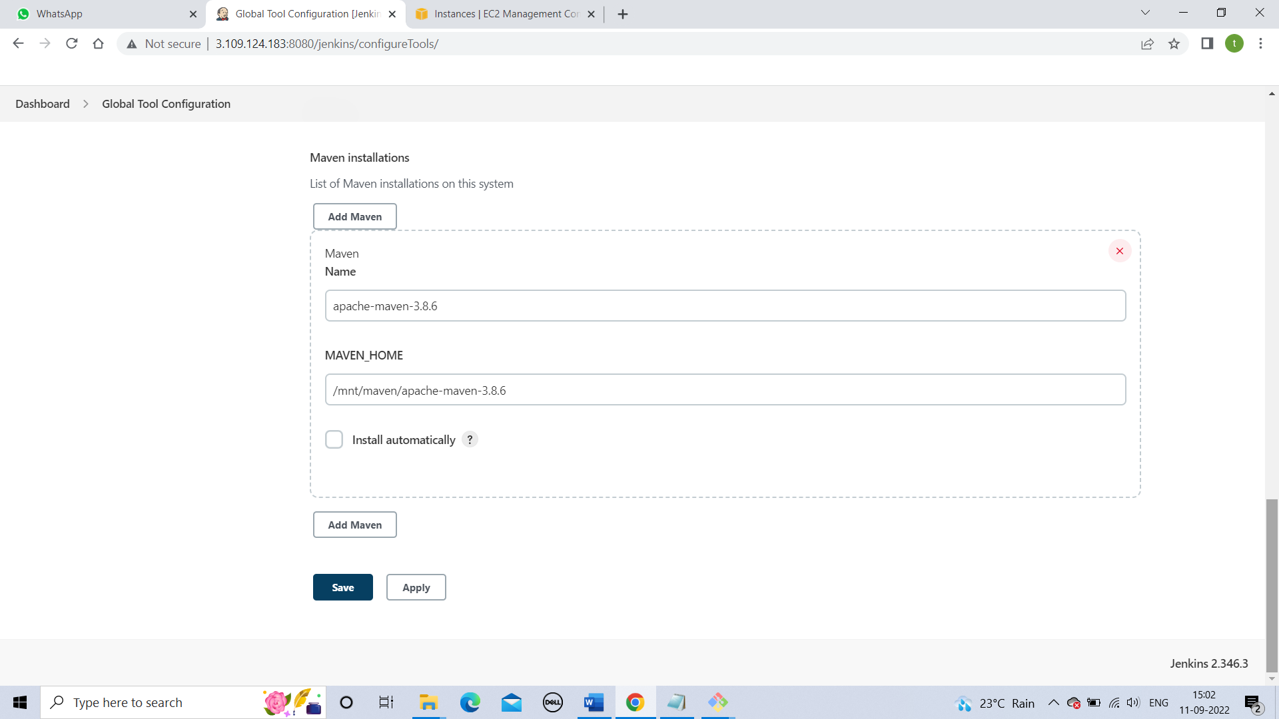

**Step 5**

**Create node using JNLP connection.**

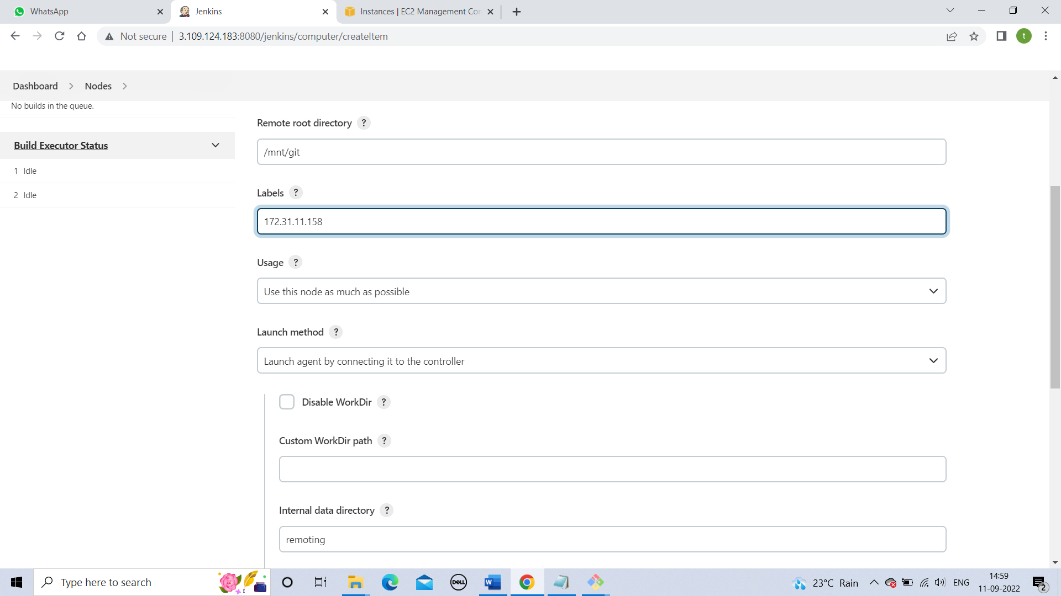

**Step 6**

**Add maven tool in node properties when you creating a node.**

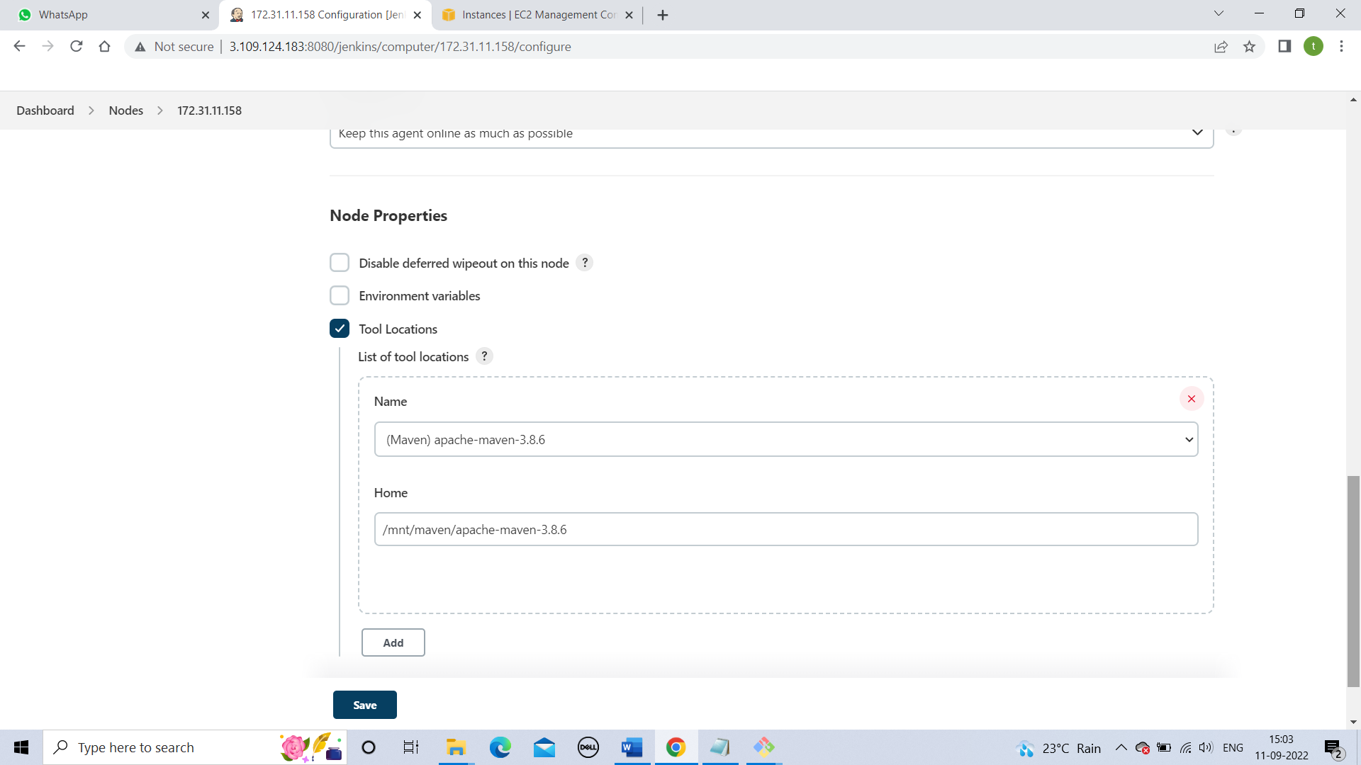

**Step 7**

**Write a new job**

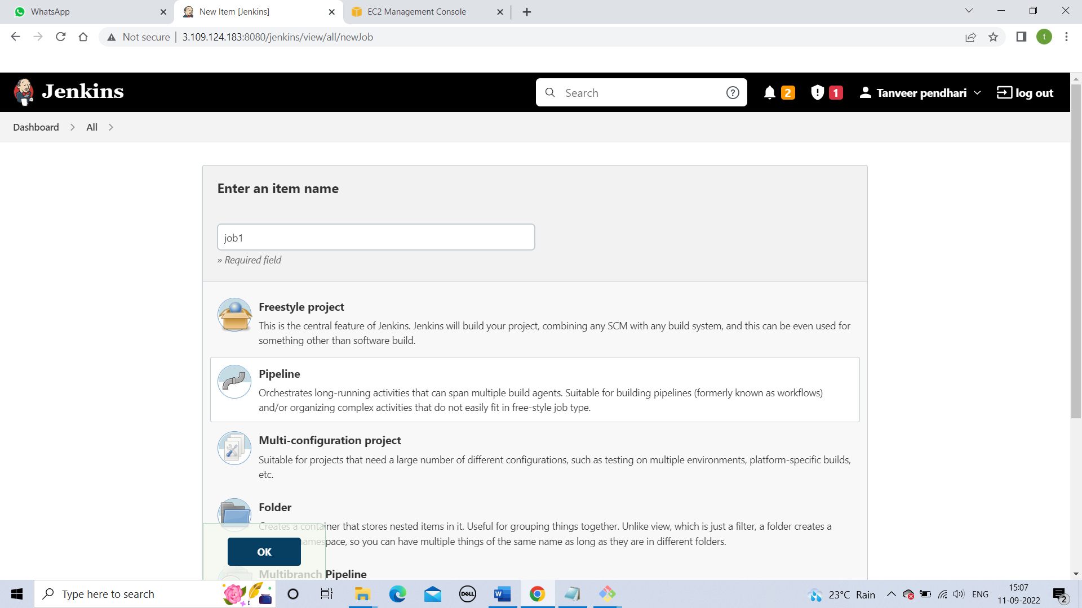

**Step 8**

**Write down your pipeline code**

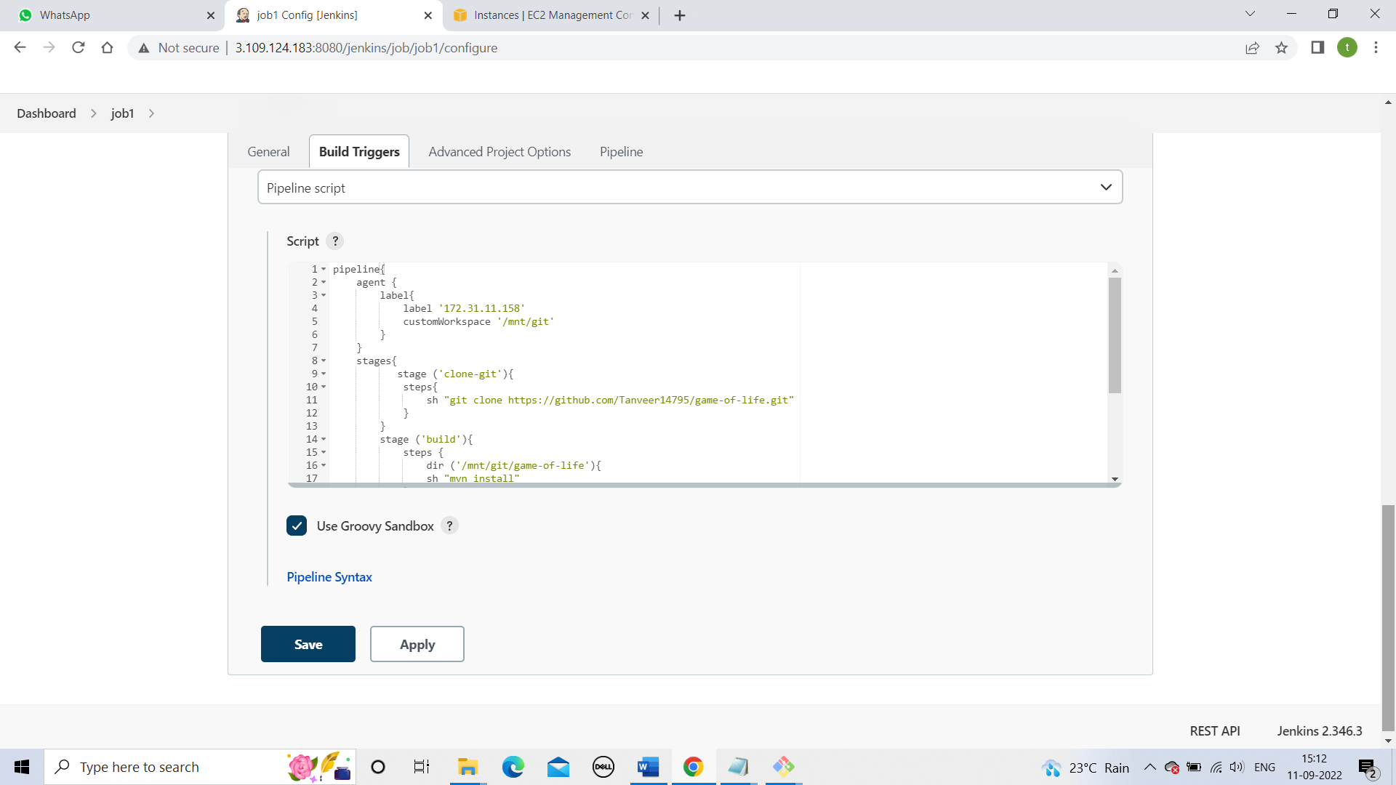

**Step 9**

**Build your job**

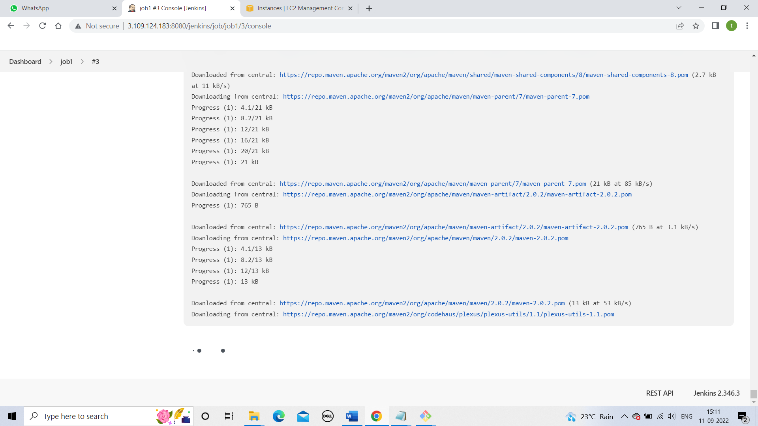

**Step 10**

**Check for error**

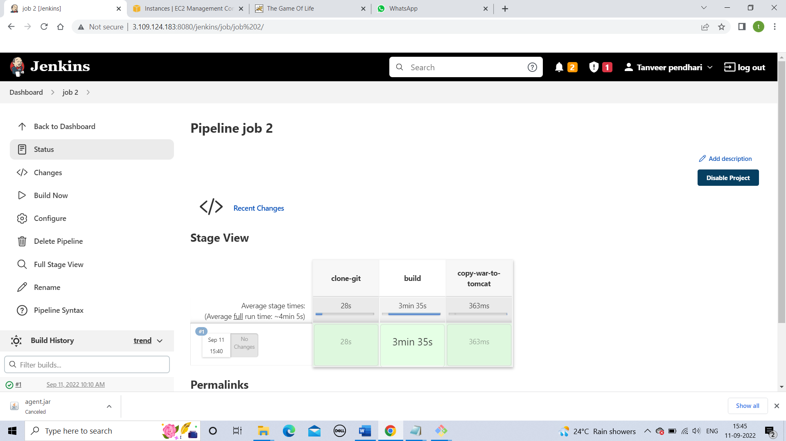

**Step 11**

**Hosting on slave server**

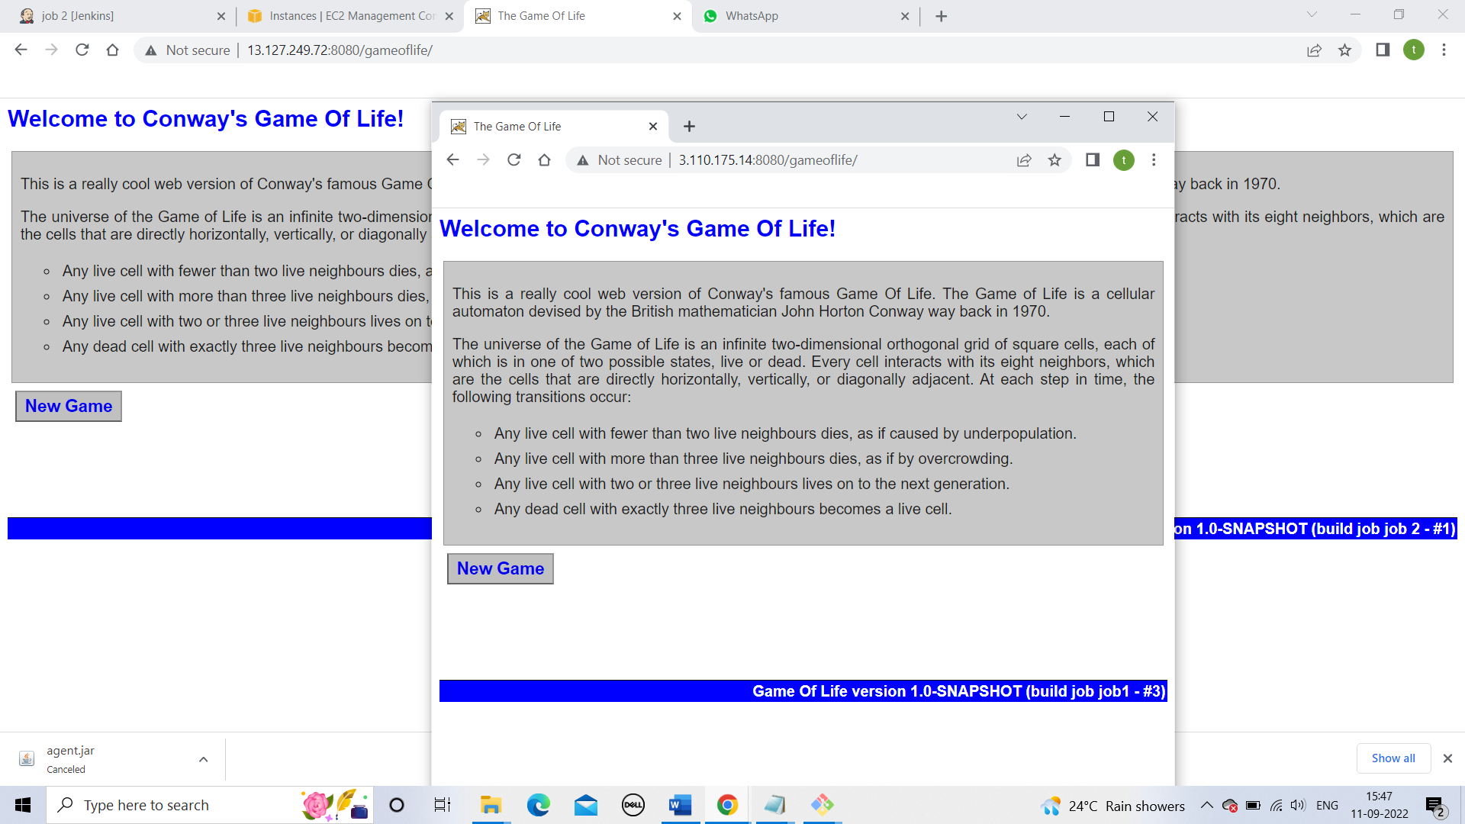

**Pipeline code**

**pipeline{**

**agent {**

**label{**

**label '172.31.46.54'**

**customWorkspace '/mnt/git'**

**}**

**}**

**stages{**

**stage ('clone-git'){**

**steps{**

**sh "git clone https://github.com/Tanveer14795/game-of-life.git"**

**}**

**}**

**stage ('build'){**

**steps {**

**dir ('/mnt/git/game-of-life'){**

**sh "mvn install"**

**}**

**}**

**}**

**stage ('copy-war-to-tomcat'){**

**steps {**

**sh "cp /mnt/git/game-of-life/gameoflife-web/target/gameoflife.war /mnt/server/apache-tomcat-9.0.65/webapps"**

**}**

**}**

**}**

**}**